Name :

Abubaker Attique

Roll no :

P20-0560

# Lab :

# 11

**Lab Task 1:**

In this activity, you are given the network address of

192.168.100.0/24 to subnet and provide the IP addressing for the

Packet Tracer network. Each LAN in the network requires at least 25 addresses for end devices, the switch and the router. The connection between R1 to R2 will require an IP address for each end of the link.

Subnet the **192.168.100.0/24** network into the appropriate number of subnets.

➔**Topology:**

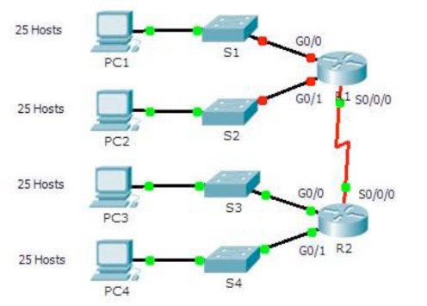

➔**Questions:**

1. **Based on the topology, how many subnets are needed?**

Ans) Based on the Topology Five Subnets are required. First Subnet for host connected with switch1, Second Subnet for host connected with switch2, Third Subnet for host connected with switch3, Fourth Subnet for host connected with switch4 and Fifth for connection between Routers.

1. **How many bits must be borrowed to support the number of subnets in the topology?**

Ans) For 5 subnets we have to borrow at least 3 bits from the Host Bits. As the given ip is “/24”, But after borrowing three Bits it would be “/27”.

1. **How many subnets does this create?**

Ans) According to the Formula of **2^no of borrowed bits**, As we borrow three bits from Host bits, so a total of **8** subnets will be created.

1. **How many usable hosts does this create per subnet?**

Ans) 2x2x2x2x2 = 32-2 = 30 usable Hosts in each Subnet.

1. **Calculate the binary value for the first fivesubnets.**

|  |  |  |  |  |  |  |  |  |  |
| --- | --- | --- | --- | --- | --- | --- | --- | --- | --- |
| **Subnet** | **Network Address** | **Bit 7** | **Bit 6** | **Bit 5** | **Bit 4** | **Bit 3** | **Bit 2** | **Bit 1** | **Bit 0** |
| 0 | 192.168.100.0 | 0 | 0 | 0 | 0 | 0 | 0 | 0 | 0 |
| 1 | 192.168.100.32 | 0 | 0 | 1 | 0 | 0 | 0 | 0 | 0 |
| 2 | 192.168.100.64 | 0 | 1 | 0 | 0 | 0 | 0 | 0 | 0 |
| 3 | 192.168.100.96 | 0 | 1 | 1 | 0 | 0 | 0 | 0 | 0 |
| 4 | 192.168.100.128 | 1 | 0 | 0 | 0 | 0 | 0 | 0 | 0 |

1. **Calculate the binary and decimal value of thenew subnet mask.**

Ans) The Binary Value is :

1st octet 2nd octet 3rd octet 4th octet **1 1 1 1 1 1 1 1 . 1 1 1 1 1 1 1 1 . 1 1 1 1 1 1 1 1 . 1 1 1 0 0 0 0 0**

The Decimal Value of the Subnet Mask is : 255.255.255.224.

1. **Fill in the Subnet Table, listing the decimalvalue of all available subnets, the first and last usable host address, and the broadcast address.**

**Repeat until all addresses are listed.**

|  |  |  |  |  |
| --- | --- | --- | --- | --- |
| **Subnet Number** | **Subnet Address** | **First Usable IP Address** | **Last Usable IP Address** | **Broadcast Address** |
| 0 | 192.168.100.0 | 192.168.100.1 | 192.168.100.30 | 192.168.100.31 |
| 1 | 192.168.100.32 | 192.168.100.33 | 192.168.100.62 | 192.168.100.63 |
| 2 | 192.168.100.64 | 192.168.100.65 | 192.168.100.94 | 192.168.100.95 |
| 3 | 192.168.100.96 | 192.168.100.97 | 192.168.100.126 | 192.168.100.127 |
| 4 | 192.168.100.128 | 192.168.100.129 | 192.168.100.158 | 192.168.100.159 |
| 5 | 192.168.100.160 | 192.168.100.161 | 192.168.100.190 | 192.168.100.191 |
| 6 | 192.168.100.192 | 192.168.100.193 | 192.168.100.222 | 192.168.100.223 |
| 7 | 192.168.100.224 | 192.168.100.225 | 192.168.100.254 | 192.168.100.255 |

➔ **Assign the subnets to the network shown in the topology.**

* 1. Assign Subnet 0 to the LAN connected to the GigabitEthernet 0/0 interface of R1:
  2. Assign Subnet 1 to the LAN connected to the GigabitEthernet 0/1 interface of R1:
  3. Assign Subnet 2 to the LAN connected to the GigabitEthernet 0/0 interface of R2:
  4. Assign Subnet 3 to the LAN connected to the GigabitEthernet 0/1 interface of R2:
  5. Assign Subnet 4 to the WAN link between R1 to R2:

**Topology:**

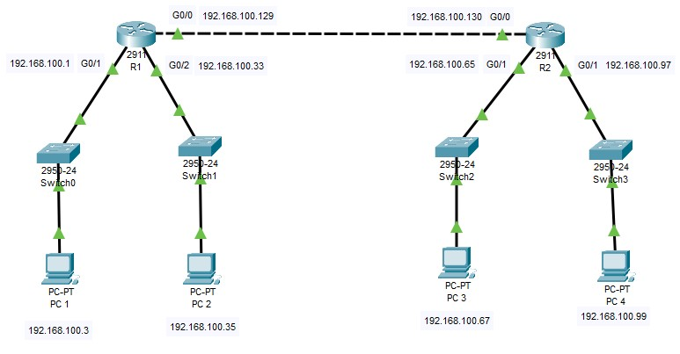

* **Document the addressing scheme:**

|  |  |  |  |  |
| --- | --- | --- | --- | --- |
| **Device** | **Interface** | **IP Address** | **Subnet Mask** | **Default Gateway** |
| **R1** | **G0/1** | 192.168.100.1 | 255.255.255.224 | 192.168.100.2 |
|  | **G0/2** | 192.168.100.33 | 255.255.255.224 | 192.168.100.34 |
|  | **G0/0** | 192.168.100.129 | 255.255.255.224 | Not Applicable |
| **R2** | **G0/1** | 192.168.100.65 | 255.255.255.224 | 192.168.100.66 |
|  | **G0/2** | 192.168.100.97 | 255.255.255.224 | 192.168.100.98 |
|  | **G0/0** | 192.168.100.130 | 255.255.255.224 | Not Applicable |
| **PC1** | **NIC** | 192.168.100.3 | 255.255.255.224 | 192.168.100.2 |
| **PC2** | **NIC** | 192.168.100.35 | 255.255.255.224 | 192.168.100.34 |
| **PC3** | **NIC** | 192.168.100.67 | 255.255.255.224 | 192.168.100.66 |
| **PC4** | **NIC** | 192.168.100.99 | 255.255.255.224 | 192.168.100.98 |

Lab Task 2:

Implement Task 4 (Lab 10) in Packet Tracer and Assign IP Addresses to Network Devices and Verify Connectivity.

**Topology:**

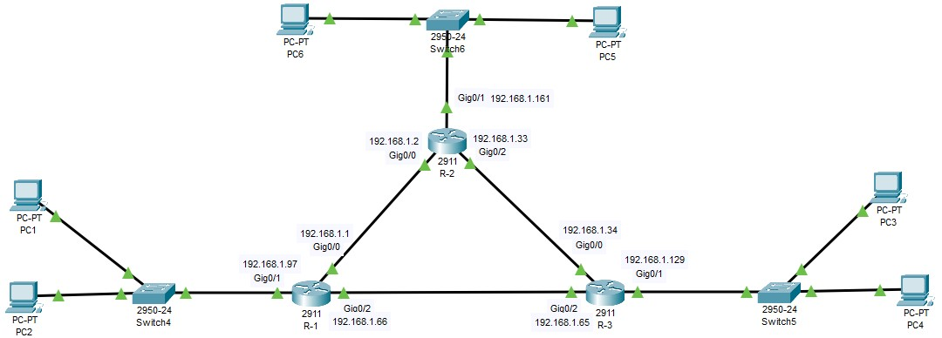

* **Addressing Scheme**

|  |  |  |  |  |
| --- | --- | --- | --- | --- |
| **Device** | **Interface** | **IP Address** | **Subnet Mask** | **Default Gateway** |
| **R-1** | **G0/0** | 192.168.1.1 | 255.255.255.224 | Not Applicable |
|  | **G0/1** | 192.168.1.97 | 255.255.255.224 | 192.168.1.98 |
|  | **G0/2** | 192.168.1.66 | 255.255.255.224 | Not Applicable |
| **R-2** | **G0/0** | 192.168.1.2 | 255.255.255.224 | Not Applicable |
|  | **G0/1** | 192.168.1.161 | 255.255.255.224 | 192.168.1.162 |
|  | **G0/2** | 192.168.1.33 | 255.255.255.224 | Not Applicable |
| **R-3** | **G0/0** | 192.168.1.34 | 255.255.255.224 | Not Applicable |
|  | **G0/1** | 192.168.1.129 | 255.255.255.224 | 192.168.1.130 |
|  | **G0/2** | 192.168.1.65 | 255.255.255.224 | Not Applicable |
| **PC1** | **NIC** | 192.168.1.99 | 255.255.255.224 | 192.168.1.98 |
| **PC2** | **NIC** | 192.168.1.100 | 255.255.255.224 | 192.168.1.98 |
| **PC3** | **NIC** | 192.168.1.131 | 255.255.255.224 | 192.168.1.130 |
| **PC4** | **NIC** | 192.168.1.132 | 255.255.255.224 | 192.168.1.130 |
| **PC5** | **NIC** | 192.168.1.163 | 255.255.255.224 | 192.168.1.162 |
| **PC6** | **NIC** | 192.168.1.164 | 255.255.255.224 | 192.168.1.162 |

**Checking Connectivity :**

